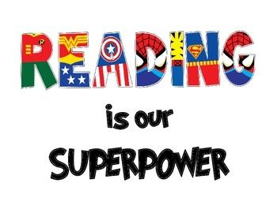
CALLING ALL SUPERHEROES
THE BRIARLAKE PTA 2019 READ-A-THON WILL BE UNDERWAY
SEPTEMBER 9-30, 2019
IT’S TIME TO READ!

If your Super Reader is having trouble finding the fundraising page, access the Briarlake Fundraising Home Page at
https://app.99pledges.com/fund/briarlakee
and search for the student’s name.

*All cash or check donations can be placed in the Read –A-Thon Box in the front office. Checks made payable to Briarlake PTA.
