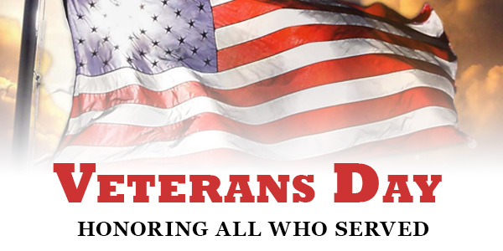
FLAG of VETERAN’S
We are very blessed to live in a country where we can enjoy so many freedoms. Let’s thank a veteran this Veteran’s Day for helping to preserve the rights and liberties we enjoy in the United States! This year we are going to be creating a “Flag of Veteran’s” at Castle Hills, to honor our family members and friends who have served or currently serving in the military.

Veteran’s Day is Saturday, November 11th, 2017 (Observing Friday, November 10th). If you would like to honor someone please fill out the form below and return to your teacher by Friday, October 27th. We will be displaying the names on a flag in the hall near the library, through the month of November.

BRING a VETERAN to LUNCH
We would also like to encourage you to bring a veteran to lunch! This will be held on Friday, November 10th (lunch will not be provided).

Veteran’s Name:_____________________________________________________________

Branch of Military Served:_____________________________________________________

Veteran’s Relationship to CHE Student: __________________________________________

Veteran’s Name:_____________________________________________________________

Branch of Military Served:_____________________________________________________

Veteran’s Relationship to CHE Student: __________________________________________

*If you have additional names, please included them on the back of this paper

