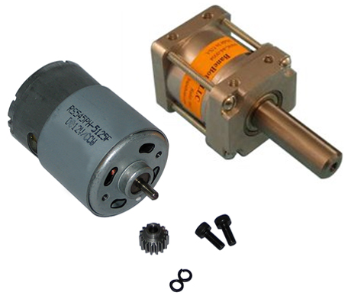

BES FAMILY

Take-apart night

Tuesday, February 20tH 6:30 – 8pm

Family Take Apart Night Registration (please print clearly) **RSVP by Thurs, Feb. 15th**

Child’s Name __________________________________________________ Grade/Teacher _______________________________

Number of Adults Attending: __________________ Number of Kids Attending: ________________________

Email Address: __________________________________________________________________________________________________

**The BES PTA invites Kids with Parents to Please Join Us** for Branchville's annual Take-Apart Night in the BES Cafeteria!

A couple of engineers (as well as a few others who love to take things apart and figure out how they work) will be leading this fun evening designed **to build curiosity and learning in your kids.** We will work with you to identify the gears, motors and circuits that make your stuff do what it does! We will hook up moving and lighted parts (motors, fans, etc.) to batteries to illustrate the inner workings of the items you take for granted in your everyday life! Kids will have a chance to see how things work and use their hands (and some cool tools) to explore items they use and see every day.

**What to Bring (and NOT BRING) to the Event:**

**Any old mechanical-type small appliances and contraptions**. Old VCRs, printers, hairdryers, toasters, electronic toys, coffee makers, phones, CD players are great. (Note: They won't be put back together -- so don't bring anything you are still using). Devices with motors, gears, moving parts are great. We have a few extra appliances so please contact us if you can’t find one of your own.

Bring your **take-apart item, a Phillips-head screwdriver, a flat-head screwdriver, some newspaper and a trash bag (you are responsible for removing your debris/parts)** to the BES cafeteria by 6:30pm. The event is only an hour-and-a half long and it takes some time to get those screws loosened – so please be on time!

SAFETY NOTICE: Printers need cartridges removed prior to arrival. All cords must be pre-cut or will be cut at the door for safety reasons. No hammers and no monitors please. We have safety goggles you can borrow but if you have your own, please bring them.

Any questions? Please contact Magda Fincham: [magda@finchamdowns.com](mailto:magda@finchamdowns.com)

**RSVP by Thursday, January 28th so we have enough goggles for everyone!**

We need to plan for space – and get enough safety goggles for everyone!