Name _______________________________________ Grade ______

Directions: Work on all problems. Show your work. Send in your solutions to Math Club.

We will discuss these problems on Tuesday, May 11 at 3:30pm via Zoom.

Problem 1
Luka is making lemonade to sell at a school fundraiser. His recipe requires times as much water as sugar and twice as much sugar as lemon juice. He uses cups of lemon juice. How many cups of water does he need?

Problem 2
Four friends do yardwork for their neighbors over the weekend, earning and respectively. They decide to split their earnings equally among themselves. In total how much will the friend who earned give to the others?

Problem 3
Carrie has a rectangular garden that measures feet by feet. She plants the entire garden with strawberry plants. Carrie is able to plant strawberry plants per square foot, and she harvests an average of strawberries per plant. How many strawberries can she expect to harvest?

Problem 4
Three hexagons of increasing size are shown below. Suppose the dot pattern continues so that each successive hexagon contains one more band of dots. How many dots are in the next hexagon?

Problem 5
Three fourths of a pitcher is filled with pineapple juice. The pitcher is emptied by pouring an equal amount of juice into each of cups. What percent of the total capacity of the pitcher did each cup receive?

Problem 6
Aaron, Darren, Karen, Maren, and Sharon rode on a small train that has five cars that seat one person each. Maren sat in the last car. Aaron sat directly behind Sharon. Darren sat in one of the cars in front of Aaron. At least one person sat between Karen and Darren. Who sat in the middle car?

Problem 7
How many integers between and have four distinct digits arranged in increasing order? (For example, is one integer.)

Problem 8
Ricardo has coins, some of which are pennies (-cent coins) and the rest of which are nickels (-cent coins). He has at least one penny and at least one nickel. What is the difference in cents between the greatest possible and least possible amounts of money that Ricardo can have?

Problem 9
Akash's birthday cake is in the form of a inch cube. The cake has icing on the top and the four side faces, and no icing on the bottom. Suppose the cake is cut into smaller cubes, each measuring inch, as shown below. How many small pieces will have icing on exactly two sides?
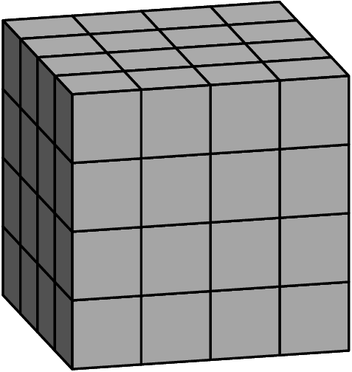

Problem 10
Zara has a collection of marbles: an Aggie, a Bumblebee, a Steelie, and a Tiger. She wants to display them in a row on a shelf, but does not want to put the Steelie and the Tiger next to one another. In how many ways can she do this?

Problem 11
After school, Maya and Naomi headed to the beach, miles away. Maya decided to bike while Naomi took a bus. The graph below shows their journeys, indicating the time and distance traveled. What was the difference, in miles per hour, between Naomi's and Maya's average speeds?
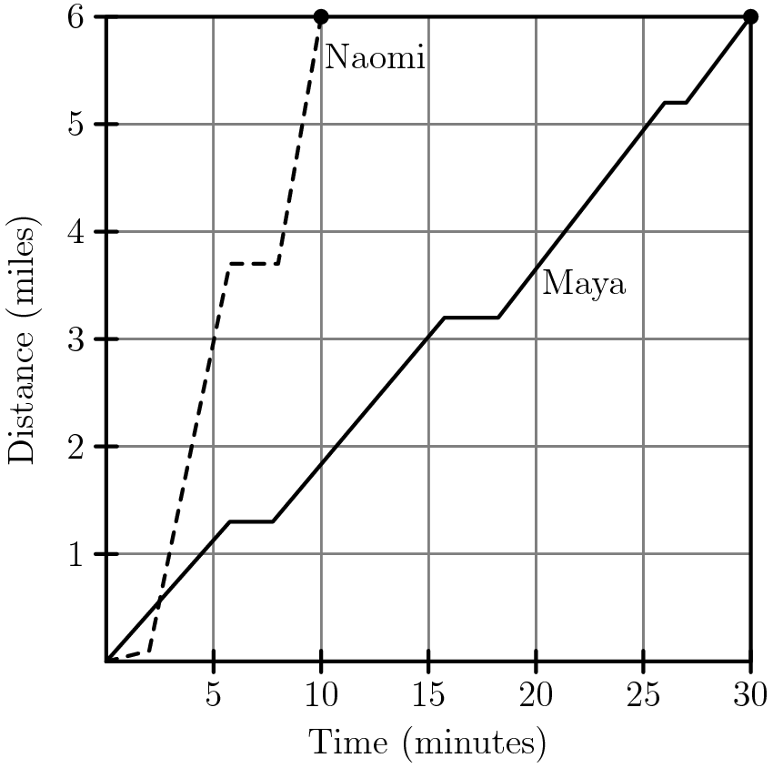

Problem 12
For a positive integer the factorial notation represents the product of the integers from to . (For example, .) What value of satisfies the following equation?

